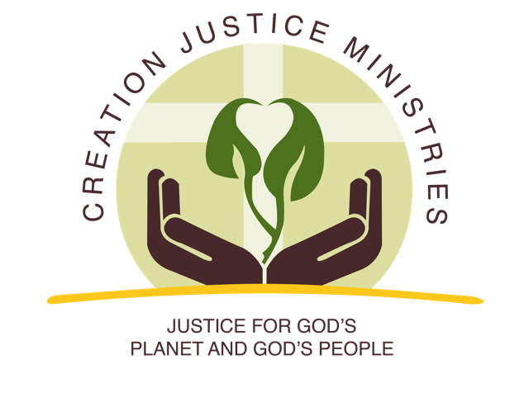
Natural gas is primarily methane, a colorless odorless gas that can escape undetected from hundreds of thousands of different sources across the oil and gas supply chain – from the well pad to processing facilities, to pipelines and everywhere in between. Industry also deliberately vents and flares natural gas during the production process.
Every year the industry leaks millions of tons of methane and other dangerous pollutants into the air. These emissions could be cut in half by implementing proven, cost-effective tools and technologies.
With strong support from Christian communities, the U.S. Bureau of Land Management (BLM) recently adopted a rule that will cut natural gas waste on federal and tribal lands. This helps ensure a fair return to tribal governments, puts our energy resources to good use, and cleans up our air.

A wasted public resource
Oil and gas companies are wasting more than $330 million worth of natural gas on federal and tribal lands each year. In fact, enough natural gas is being wasted to supply a city the size of Chicago for a year.
Taxpayers could lose out on $800 million over the next decade as a result of venting and flaring natural gas alone in a business-as-usual scenario. Half of those revenues go to reclamation and the general treasury. The other half of those revenues would go to energy-producing states to help fund education, road, bridges, and more.

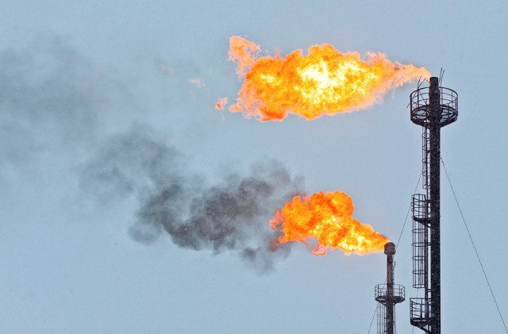
Families at risk
When methane is released into the air, so too are harmful pollutants that have significant public health consequences. This includes toxic chemicals such as benzene, which are linked to cancer, and other ozone-forming pollutants that can trigger asthma attacks. The Oil and Gas Threat Map shows where communities’ air is at risk. Oil and gas activity on public and tribal lands disproportionately harms Native American and Latino communities. A recent report "Latino Communities at Risk: The Impact of Air Pollution from the Oil and Gas Industry" nearly 3 percent of all Latinos in the United States (1.8 million) live in areas where toxic air pollution exceeds EPA's level of concern.
Ground-level ozone pollution is further compounded due to increased warming caused by methane pollution. Over the next two decades, methane will trap 80 times more heat in the atmosphere than the same amount of carbon dioxide.

Cost-effective measures that create jobs
“The Earth is the Lord’s, and all that is in it.” Psalm 24:1
As Christians, we believe we are stewards, not owners, of the gifts of God’s creation. Methane is a gift of creation that brings our communities light and heat. Wasting methane is poor stewardship. We are called to rightly share the gifts of creation with each other, and with future generations.
Companies can reduce waste on public and tribal lands for about than a penny per Mcf (thousand cubic feet of gas). That is less than a penny on the dollar.

Cutting methane spurs innovation and creates jobs. More than 75 companies are now active in methane mitigation with over 500 locations across 46 states. This includes the State of Nevada which is home to companies that sell equipment and provide service to cut methane emissions to the oil and gas industry.

States are leading the way
Leading states such as Colorado and Wyoming have shown we can cut waste and have put similar waste and pollution measures in place.

Since Colorado put its nationally leading methane rules in place, natural gas production and the number of active wells have increased. In a recent survey, 7 out of 10 Colorado operators said benefits of regularly checking equipment for leaks outweigh costs. And since Colorado’s rules went into place, regulators report a 75% reduction in equipment leaks.

Broad agreement to act
A January 2016 Colorado College poll conducted by Republican polling firm Public Opinion Strategies and Democratic frim Fairbank, Maslin, Maullin, Metz & Associates found that 80 % of westerners support common sense rules that cut natural gas waste on public lands.

In addition to Creation Justice Ministries a broad and diverse array of western stakeholders support the BLM natural gas waste rule, including: the Colorado Council of Churches, the Wyoming Association of Churches, the New Mexico Conference of Churches, the Arizona Faith Network, the Mormon Environmental Stewardship Alliance, Eco-Justice Ministries, and Interfaith Power and Light chapters across the United States. In addition to religious communities, upwards of western 100 local officials, Latino organizations such as Hispanic Access Foundation and HECHO, Rocky Mountain Farmers Union, Vet Voice Foundation, Taxpayers for Common Sense, Partnership for Responsible Business, American Lung Association, sportsmen organizations, more than 60 public health professionals across five states, tribal grassroots organizations and officials, among others.

