Faith Perspective: Being Ready to Talk Loss and Damage for COP 21
Faith communities approach discussions about climate change from the perspective of those who are most vulnerable to its effects. Faith communities are globally interconnected. Fellow believers as well as missionaries live in small island nations and along shoreline communities most at risk for losing their lives, not to mention their cultures, livelihoods and lands. We call on the United States to prioritize the needs of the most vulnerable during the COP 21 climate negotiations in Paris. In particular, U.S. negotiators need to take Loss and Damage into account.
Loss and Damage is a different issue than Mitigation, or Adaptation
- Mitigation involves ensuring that nations develop in a way that avoids making climate change even worse. (e.g., by reducing greenhouse gas emissions and building infrastructure for clean energy).
- Adaptation means ensuring that those who are most vulnerable to the effects of climate change have the tools to cope (e.g., by building severe weather warning systems and natural disaster resilience planning infrastructure).
- Loss and Damage refers to harm caused by climate change that is unavoidable and to which it is not possible to adapt, such as small island nations becoming entirely submerged. Part of planning for Loss and Damage is financial. We must also address permanent changes in food production and distribution systems, sovereignty of island nations, and mass migration of peoples.
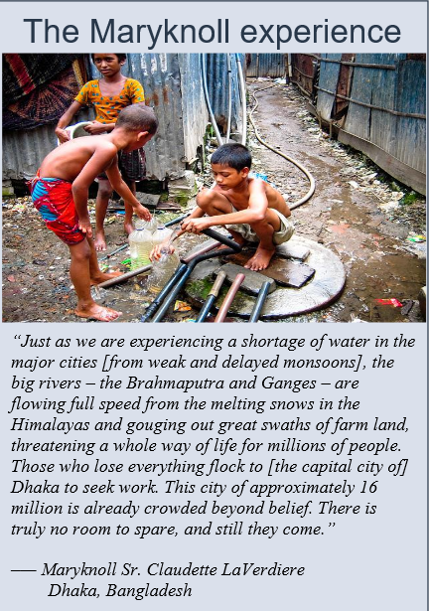
The time to address Loss and Damage is now. Even if we succeeded in reducing production of greenhouse gasses immediately, catastrophic effects of emissions by the U.S. and other industrialized countries over the years are taking a toll now.
Being ready to talk about Loss and Damage in Paris is politically necessary. Sidelining or altogether ignoring Loss and Damage issues could imperil getting meaningful agreement at COP 21. Loss and Damage is already a critical issue for the majority of developing countries, including certain island nations as well as some larger nations with low-lying coastal areas. The very survival of these nations and their peoples is at stake. Unless the underlying agreement meaningfully addresses Loss and Damage, there may be no agreement in Paris.
Planning for Loss and Damage is the right thing to do. It is part of our moral responsibility to be actively engaged in planning for Loss and Damage, as the U.S. is one of the largest emitters of greenhouse gases.
Any agreement in Paris must include Loss and Damage. Specifically, we need a clear, strong and distinct reference to the importance of addressing loss and damage in the Paris agreement text. We also need a structural framework to address loss and damage in the agreement, building upon and developing the work of the Warsaw International Loss and Damage mechanism. This should include finance, a climate displacement facility and approaches to address permanent loss and damage

